Exp 7

% Calculation and Verification of Frequency Deviation
% and Modulation Index of FM Signal clc;
clear; close all;
%% Message Signal Parameters Am = 2; % Message amplitude (V)
fm = 500; % Message frequency (Hz)
%% Carrier Signal Parameters Ac = 1; % Carrier amplitude (V)
fc = 10000; % Carrier frequency (Hz)
%% FM Parameters
kf = 250; % Frequency sensitivity (Hz/V) fs = 100000; % Sampling frequency (Hz)

T = 0.01; % Simulation duration (s)
%% Time Vector t = 0:1/fs:T;
%% Message Signal
m = Am*cos(2*pi*fm*t);
%% Frequency Deviation delta_f = kf*Am;
%% Modulation Index beta = delta_f/fm;
%% FM Signal
fm_signal = Ac*cos(2*pi*fc*t + beta*sin(2*pi*fm*t));
%% Display Parameters
fprintf('Carrier Frequency (fc) = %.0f Hz\n',fc); fprintf('Message Frequency (fm) = %.0f Hz\n',fm);

fprintf('Message Amplitude (Am) = %.0f V\n',Am); fprintf('Frequency Sensitivity (kf) = %.0f Hz/V\n',kf); fprintf('\nFrequency Deviation (Delta f) = %.2f Hz\n',delta_f); fprintf('Modulation Index (Beta) = %.2f\n',beta);
%% Verification beta_verify = delta_f/fm;
fprintf('Verified Modulation Index = %.2f\n',beta_verify);
%% Verification Check tolerance = 1e-6;
if abs(beta - beta_verify) < tolerance fprintf('\nVerification Successful\n'); else
fprintf('\nVerification Failed\n'); end
%% Plotting figure; subplot(2,1,1);
plot(t,m,'LineWidth',1.5); grid on;
title('Message Signal'); xlabel('Time (s)');
ylabel('Amplitude (V)');
subplot(2,1,2); plot(t,fm_signal,'LineWidth',1); grid on;
title('FM Signal');

xlabel('Time (s)');
ylabel('Amplitude (V)');

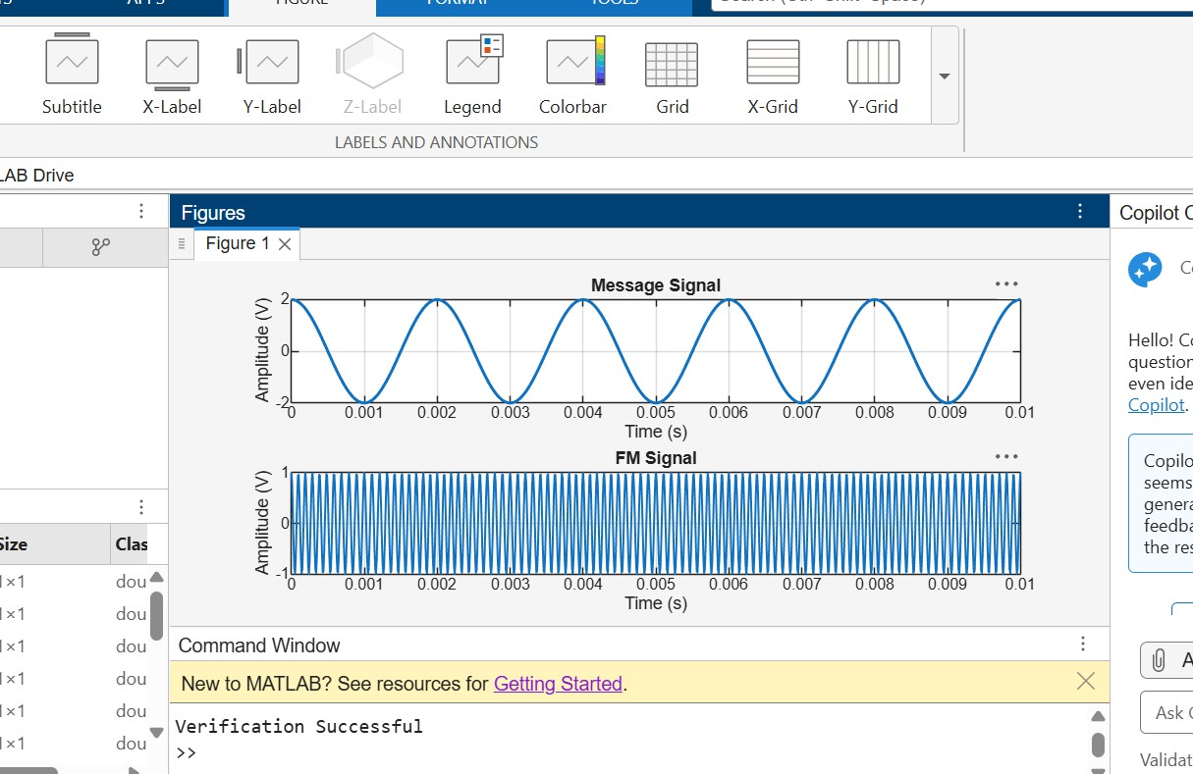

Exp 8

clc; clear; close all;
% Parameters
Am = 1; % Message Amplitude (V) fm = 100; % Message Frequency (Hz) Ac = 5; % Carrier Amplitude (V)
fc = 1000; % Carrier Frequency (Hz)
fs = 20*fc; % Sampling Frequency (Hz) kp = pi/2; % Phase Sensitivity (rad/V)
% Time Vector t = 0:1/fs:4/fm;
% Message Signal
m = Am*sin(2*pi*fm*t);
% PM Signal
pm = Ac*cos(2*pi*fc*t + kp*m);
% Phase Deviation beta = kp*Am;
% FFT
N = length(pm);
f = linspace(-fs/2,fs/2,N);
PM_FFT = abs(fftshift(fft(pm)))/N;
% Power Spectral Density
PSD = (abs(fftshift(fft(pm))).^2)/(N*fs);
% Approximate Bandwidth BW = 2*(beta+1)*fm;
fprintf('Phase Deviation = %.2f radians\n',beta); fprintf('Estimated Bandwidth = %.2f Hz\n',BW);
% Plotting
figure('Name','PSD Analysis of PM Signal','NumberTitle','off');

subplot(2,2,1);
plot(t,m); title('Message Signal'); xlabel('Time (s)'); ylabel('Amplitude'); grid on; subplot(2,2,2);
plot(t,pm);
title('Phase Modulated Signal');

xlabel('Time (s)'); ylabel('Amplitude'); grid on; subplot(2,2,3); plot(f,PM_FFT);
title('Frequency Spectrum of PM Signal'); xlabel('Frequency (Hz)'); ylabel('Magnitude');
grid on; subplot(2,2,4);
plot(f,PSD);
title('Power Spectral Density'); xlabel('Frequency (Hz)'); ylabel('PSD');
grid on;

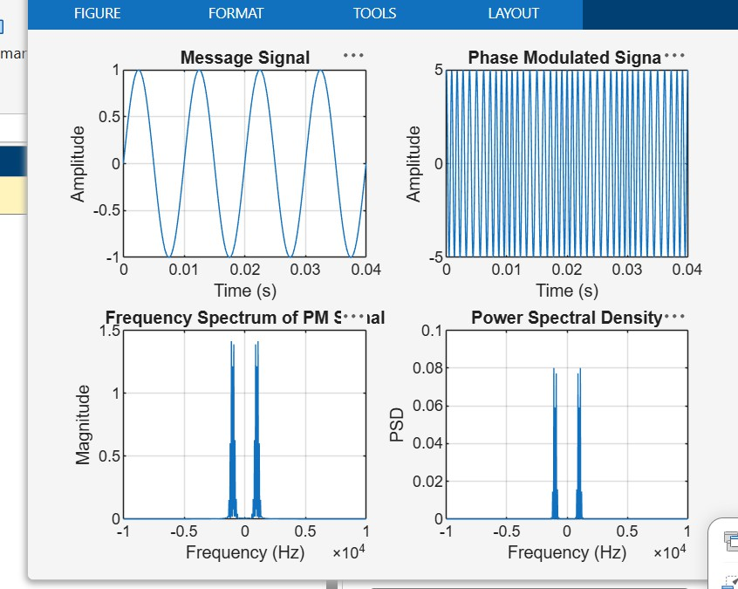

Exp 9

clc; clear; close all;
% Parameters

fs = 100000;
t = 0:1/fs:0.02; fm = 500;
fc = 5000;
% Message Signal m = cos(2*pi*fm*t); c = cos(2*pi*fc*t);

% AM Modulation
am = (1 + m).*cos(2*pi*fc*t);
% Add AWGN Noise
noisy = awgn(am,10,'measured'); % 10 dB SNR
% Envelope Detection env = abs(hilbert(noisy));
% Display Results figure; subplot(5,1,1) plot(t,m)
title('Message Signal') grid on
subplot(5,1,2) plot(t,c) title('Carrier Signal') grid on subplot(5,1,3) plot(t,am)
title('AM Signal') grid on subplot(5,1,4) plot(t,noisy)
title('AM Signal with AWGN Noise') grid on
subplot(5,1,5) plot(t,env) title('Recovered Signal') grid on

